* Enter the grace period in days and hit ENTER for the instruction.

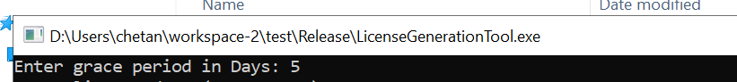

* License Date should be entered in the requested format (YYY- MM-DD). Make sure to follow the exact format. Hit ENTER for the next instruction.
* Time should be entered in 24 Hour format (HH:MM:SS). Make sure to follow the exact format. Hit ENTER.
* The file is generated with **license.txt** in a same directory.

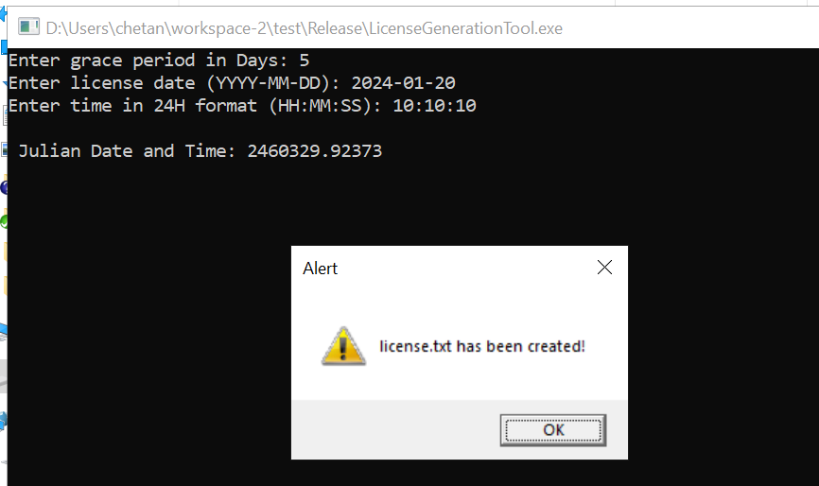

* Keep the license.txt file in dist\bin directory.